Course Registration System
Class Diagram:
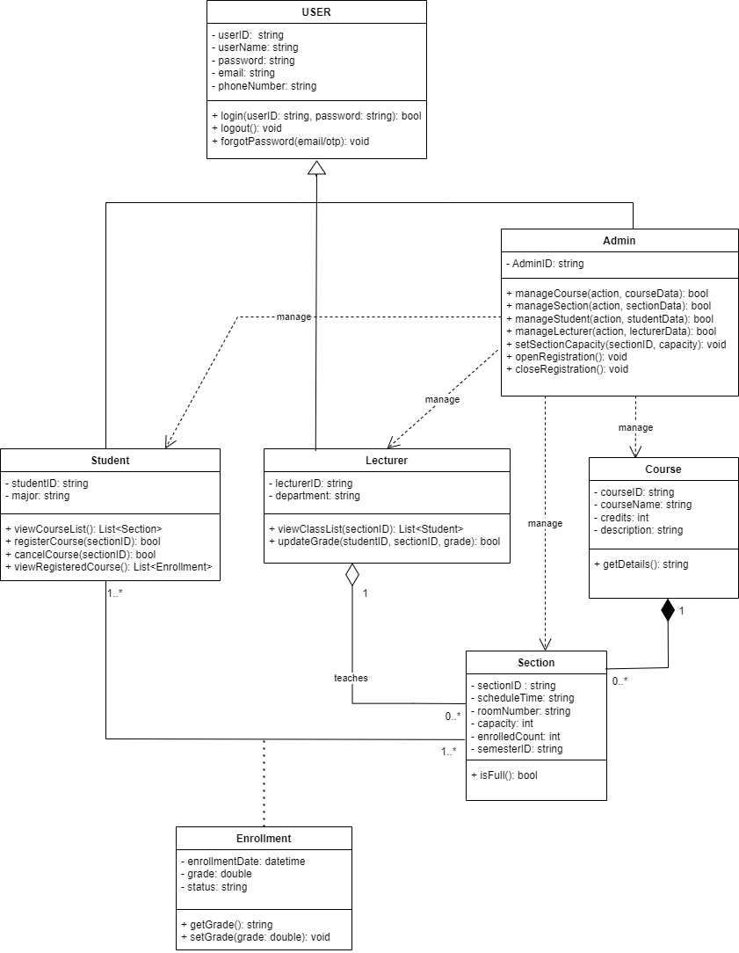

3.1. Overview
The Class Diagram describes the static structure of the Course Registration System, illustrating the main classes, their attributes, methods, and relationships. The system supports three primary user roles: Student, Lecturer, and Admin, each inheriting from a common abstract class User. The design follows object-oriented principles to ensure modularity, reusability, and maintainability.

3.2. User Class Hierarchy

3.2.1. User (Abstract Class)
The User class is an abstract superclass representing common information and behaviors shared by all system users.
Attributes:
- userId: String – Unique identifier for the user.
- userName: String – Full name of the user.
- email: String – Email address used for communication.
- phoneNumber: String – Phone number used for OTP-based password recovery.
- password: String – Encrypted user password.
Methods:
- login(userId: String, password: String): boolean – Authenticates the user.
- logout(): void – Logs the user out of the system.
- forgotPassword(): void – Supports password recovery via Email or OTP.
This abstraction reduces duplication and enforces consistency across all user roles.

3.2.2. Student Class
The Student class represents students who use the system to register for courses.
Attributes:
- studentID: String – Unique student identifier.
- major: String – Student’s academic major.
Methods:
- viewCourseList(): List<Section> – Displays all open course sections.
- registerCourse(sectionID): boolean – Registers the student for a course section.
- dropCourse(sectionID): boolean – Cancels a registered course within the allowed period.
- viewRegisteredCourses(): List<Enrollment> – Displays all successfully registered courses.

3.2.3. Lecturer Class
The Lecturer class represents faculty members responsible for teaching and grading.
Attributes:
- lecturerID: String – Unique lecturer identifier.
- department: String – Academic department of the lecturer.
Methods:
- viewClassList(sectionID): List<Student> – Views students enrolled in a course section.
- inputGrade(studentID, sectionID, grade): bool – Inputs or updates grades for students.

3.2.4. Admin Class
The Admin class manages system configuration and data.
Attributes:
- adminId: String – Unique administrator identifier.
Methods:
- manageCourse() / manageSections() / manageStudents() / manageLecturers(): Bool - methods to Create, Read, Update, or Delete (CRUD) system entities.
- setSectionCapacity(): void - Sets the maximum number of students for a section.
- openRegistration() / closeRegistration(): void – Controls the registration window.
The relationships between Admin and other entities represent management (control) relationships, not ownership.
3.3. Course and Section Management
3.3.1. Course Class
The Course class stores general information about academic courses.
Attributes:
- courseId: String
- courseName: String
- credits: int
- description: string
Methods:
- getDetails(): String – Provides a summary of the course info.

3.3.2. Section Class
Represents a specific instance of a course held at a specific time and place.
Attributes:
- sectionID: String
- scheduleTime: String
- roomNumber: String
- capacity: int
- enrolledCount: int
- semesterID: String
Methods:
- isFull(): boolean – Checks if the section has reached its maximum capacity.
3.4. Enrollment Class
An association class that records the relationship between a Student and a Section.
Attributes:
- enrollmentDate: datetime
- grade: double
- status: String
Methods:
- getGrade(): String
- setGrade(grade): void

3.5. Class Relationships Summary
- Inheritance:
Student, Lecturer, and Admin inherit from User.
- Associations:
  - Admin manages Student, Lecturer, Course, and Section
  - Lecturer teaches one or more Section instances.
- Composition: A Course is composed of multiple Section instances (1 to 0..*)
- Many-to-Many Relationship: Managed via the Enrollment class between Student and Section.
3.7. Conclusion
The Class Diagram accurately models the functional requirements of the Course Registration System. It applies object-oriented design principles, separates concerns effectively, and ensures system extensibility and maintainability. The design supports secure authentication, structured course registration, grading management, and administrative control.

